|  |
| --- |
|  |
|  |

|  |  |  |  |  |  |
| --- | --- | --- | --- | --- | --- |
| REVISION HISTORY | | | | | |
| Ver. | Description of Change | Author | Date | Approved | |
| Name | Effective Date |
| 1.0 | Initial status | Olga_Hilko | 04-DEC-2017 |  |  |
|  |  |  |  |  |  |
|  |  |  |  |  |  |

Contents

2. DIM objects 3

3. Grants 4

4. Packages 4

5. DimDate (execute immediate, loop) 5

6. Test Data on 3NF 5

# DIM objects

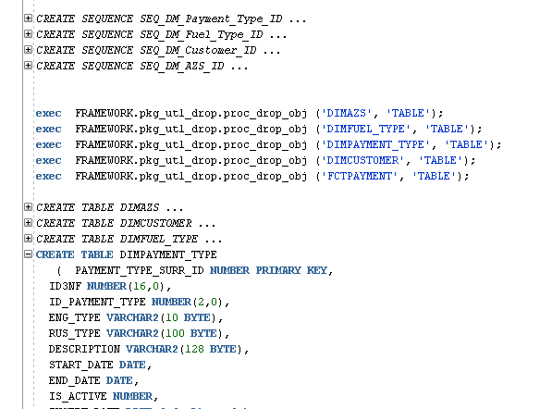

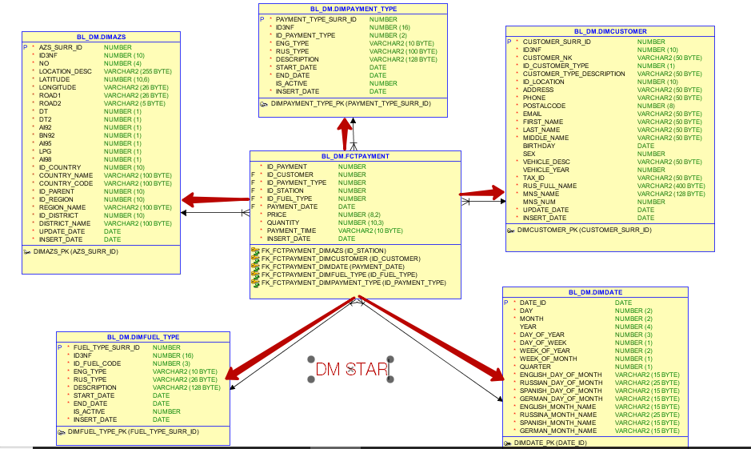

# Grants

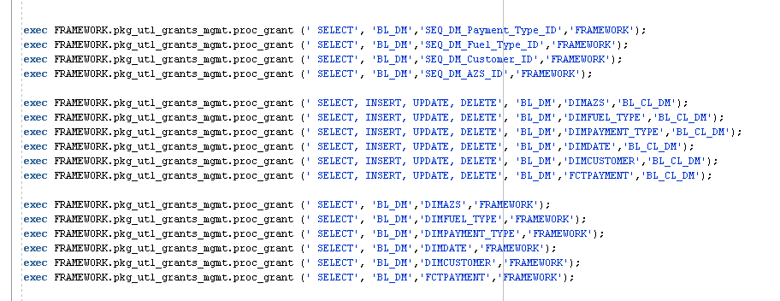

# Packages

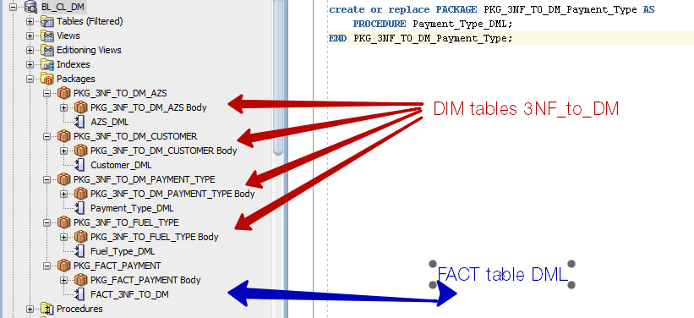

# DimDate (execute immediate, loop)

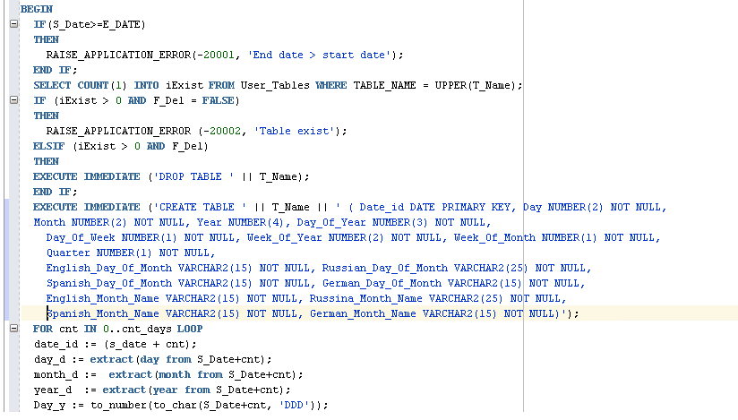

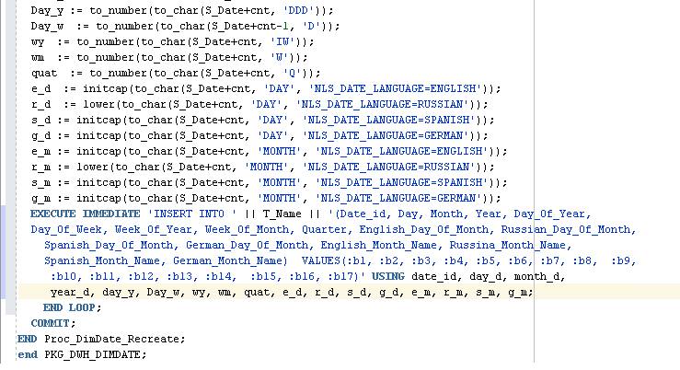

# Test Data on 3NF

row count before insert

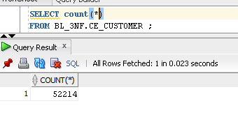

data before insert

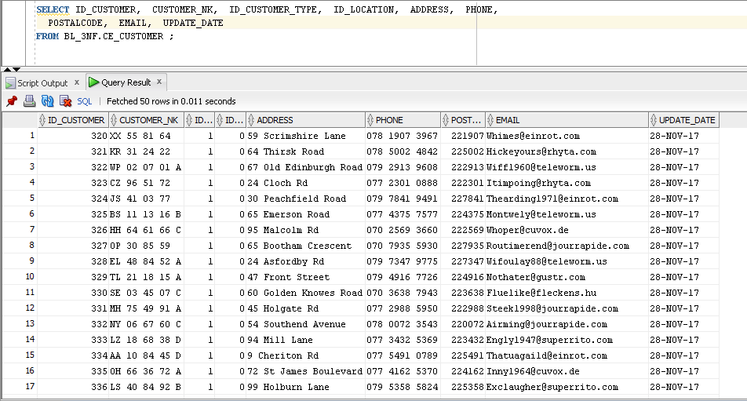

update/insert of new data

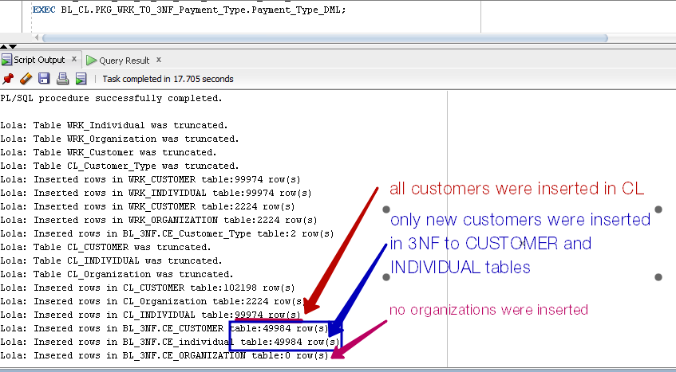

row count after insrt/update

